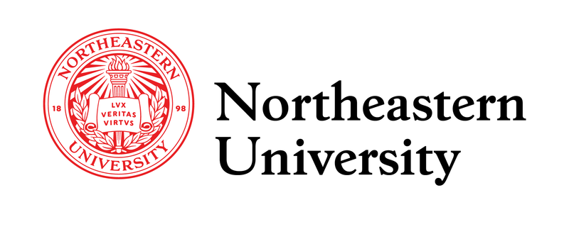

**Email Notifications for Northeastern’s Workday Portal**

Contents

User Questions 4

Executive Summary 8

Problem Statement 8

Survey Insights 9

Target Audience 10

Personas: 11

Solution Overview 11

High-Level User Experience: 11

Goals and Metrics 12

User Journey Flowchart Student Journey 13

Recruiter Journey 14

Product Backlog 15

User Story 1: Configure Notification System as a Workday Admin 15

User Story 2: Select Notification Preferences 16

User Story 3: Receive Reliable Preference-Based Notifications 17

User Story 4: Confirm Notification Preference Status 18

User Story 5: Ensure Accessibility for Preference-Based Notifications 19

User Story 6: Test Notification System Functionality 20

Prioritization Summary 21

Prototype Link: 22

Technical Considerations 22

Feature Prioritization 23

Roadmap 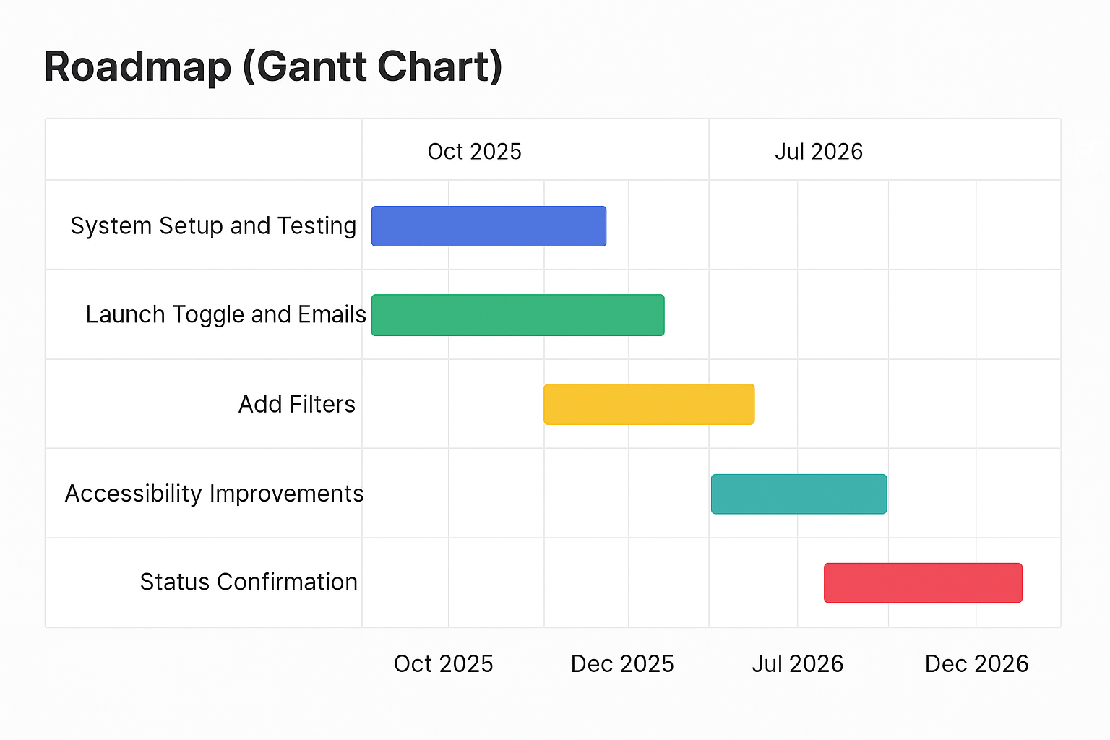 24

Risks and Mitigations 25

Feedback Collection 25

Reference list 25

# User Questions

# Executive Summary

Northeastern University’s Workday job portal lacks notifications, causing students to miss on-campus job opportunities. This proposal offers a simple email notification feature to alert students of new postings. A prototype (https://husky-hub-alert-emails.lovable.app/) demonstrates the solution, enhancing job access for students.

# Problem Statement

Northeastern University’s Workday job portal lacks automated notifications, compelling all students seeking on-campus jobs to manually check postings multiple times daily. This inefficiency creates three core problems:   
(1) absence of real-time alerts,   
(2) repetitive manual checks, and   
(3) missed job opportunities,   
as roles often fill within 24–48 hours. A May 2025 survey of 63 students (conducted via WhatsApp and r/NEU) found that 73% miss opportunities due to delayed awareness, with 80% reporting frustration from the difficulty of staying updated. Additionally, 46% spend 10–20 minutes per session checking Workday, straining academic and financial stability. User interviews reveal students struggle to balance job searches with coursework, exacerbating stress. Recruiters face delays in filling roles, hindering operational efficiency. External research, including Iowa State’s Job Alerts system (iastate.edu, 2019) and Lesley University’s notification framework (support.lesley.edu, 2024), demonstrates that automated alerts reduce missed opportunities. Carleton College’s notification preferences (carleton.edu, 2023) further validate this approach. This pervasive issue demands a streamlined solution to enhance job accessibility for all students.

# Survey Insights

A May 2025 survey of 63 students (via WhatsApp and r/NEU) revealed:

* **Missed Opportunities**: 73% (46 students) missed jobs due to delayed awareness.  
  A graph with a bar and a number of numbers

  AI-generated content may be incorrect.
* **Check Frequency**: 36.5% check 2–3 times weekly, 34.9% daily, with 46% spending 10–20 minutes per session.
* **Time Spent:** 46% spend 10–20 minutes per session.
* **Satisfaction**: Average portal satisfaction is 3.1/5, with 47.6% rating it neutral.
* **Pain Points**: Lack of alerts is the top issue (mean: 4.2/5), followed by feedback delays (3.7/5) and difficulty finding postings (3.3/5).
* **User Needs**: 93.7% would enable a notification toggle; 71.4% prefer email alerts.  
  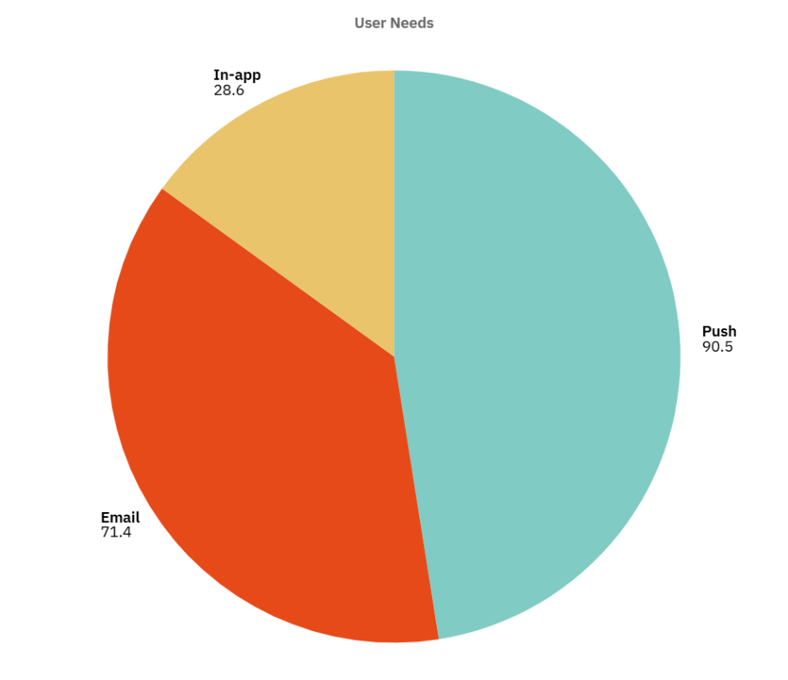

**Source**: - Survey of 63 students

# Target Audience

**User Segment**: The target audience is all Northeastern University students seeking on-campus jobs. This diverse group, encompassing undergraduate and graduate students across all campuses, relies on the Workday job portal for employment opportunities open to every enrolled student. Their shared goal is to access jobs that support financial stability, academic schedules, and career growth.

# Personas:

* **Emma, 35, Recruiter**: A Northeastern staff member posting on-campus jobs on Workday for departments like IT Services or Library. Emma aims to fill roles quickly to meet operational needs. She struggles with delayed applications due to students missing postings, requiring manual follow-ups and extending hiring timelines.
* **Sam, 22, Student**: An enrolled Northeastern student seeking on-campus jobs to support financial stability and career growth. Sam checks Workday frequently but misses opportunities as roles fill within days. Sam needs timely alerts to apply promptly while balancing academics.

# Solution Overview

An email notification system integrated into Northeastern University’s Workday job portal alerts all students seeking on-campus jobs about new postings, ensuring timely awareness to support financial stability and career growth while enabling recruiters to fill roles efficiently. By sending reliable email alerts with clear job details and application links, the system eliminates constant manual checks, and customizable preferences allow students like Sam to tailor alerts to their academic schedules, simplifying applications. When a recruiter like Emma posts a job, the system notifies students promptly, allowing Sam to apply quickly, and Emma to review applications and fill roles effectively, enhancing job access and university operations.

# High-Level User Experience:

1. Students log into Workday.
2. Sees pop-up: “Never miss a job! Enable daily email alerts.”
3. Clicks “Enable Job Emails” toggle.
4. Receives daily email with new postings (e.g., “IT Support, Boston Campus”).
5. Applies within 24 hours, beating competitive windows.

# Goals and Metrics

**Goals**:

* Save students 10–20 minutes weekly by eliminating manual checks.
* Increase job applications by 30% by reducing 73% missed opportunities.
* Improve Workday satisfaction from 3.1/5 to 4/5.

**Success Metrics**:

* **Adoption Rate**: 80% of Workday users enable email alerts within 3 months (93.7% interest).
* **Enrollment Rate:** Achieve a 25% increase in the percentage of students hired for on-campus jobs within 6 months.
* **Satisfaction**: Achieve a 4/5 rating via post-launch survey.

# User Journey Flowchart Student Journey

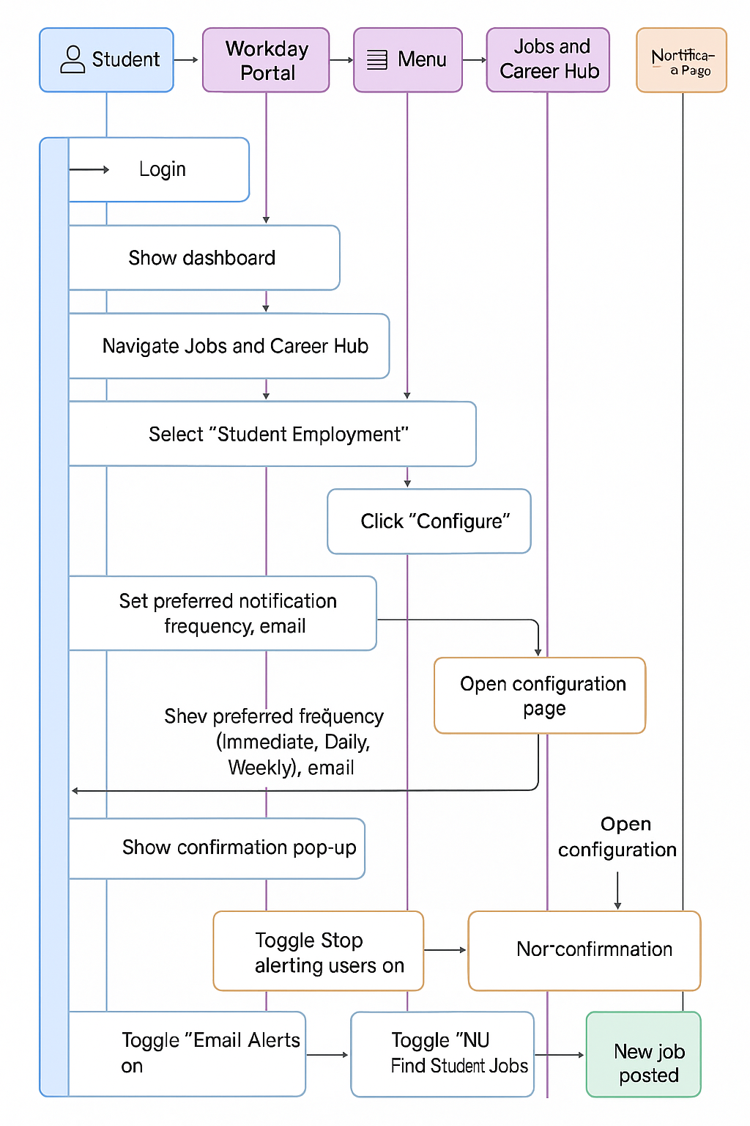

## Recruiter Journey

# Product Backlog

The prioritization below reflects the MoSCoW framework for the email notification system in Northeastern University’s Workday portal, balancing impact on timely job access and hiring efficiency with feasibility within Workday’s capabilities and a 1–2 month implementation timeline.

## User Story 1: Configure Notification System as a Workday Admin

As a Workday admin, I want to enable email notifications for job postings, so students can receive alerts and recruiters can fill roles efficiently.  
**Acceptance Criteria**:

* A “Notification Settings” section in the Workday admin dashboard includes a toggle to enable/disable job posting notifications.
* Admin can view a list of active notification types (e.g., student job alerts).
* Configuration takes <5 minutes via a toggle and “Save” button.
* Feature is accessible on desktop Workday admin interfaces.
* Admin receives a confirmation email upon enabling notifications.

**Context**:

* Admins need to activate notifications to ensure students like Sam receive job alerts, enabling recruiters like Emma to hire promptly.

**Priority**: Must Have (MoSCoW)  
**Reason**: Foundational setup is critical for system operation, using Workday’s standard admin tools. Simple configuration requires minimal effort (1–2 weeks).

## User Story 2: Select Notification Preferences

As a student seeking on-campus jobs, I want to select my preferred notification frequency (immediately or daily) for new job postings, with immediate as the default, so I can receive timely alerts to reduce missed opportunities.

**Acceptance Criteria:**

* A “Job Notification Preferences” section in the “Find Jobs” dashboard offers two options: “Immediately” (within 5 minutes, default) or “Daily” (8 AM EST digest).
* A pop-up on first login prompts, “Choose your job alert preference: Immediately (recommended) or Daily?” with “Immediately” pre-selected.
* Selecting a preference takes <30 seconds via radio buttons and a “Save” button.
* Emails reflect the chosen frequency (e.g., immediate emails, daily digests).
* Pop-up is dismissible, reappearing weekly until a preference is selected.
* Feature works on desktop and mobile Workday interfaces.

**Context:**

* Students like Sam need flexible notification options to stay informed without constant manual checks, supporting financial stability and career growth.

**Priority:** Must Have (MoSCoW)

**Reason:** Core feature enabling timely alerts, using Workday’s dashboard customization. High demand justifies priority, with straightforward implementation (1–2 weeks).

## User Story 3: Receive Reliable Preference-Based Notifications

As a student seeking on-campus jobs, I want my selected notification preference (immediately or daily) to deliver reliable emails, with immediate as the default, so I can apply to jobs before they fill quickly.

**Acceptance Criteria:**

* Immediately (default): Emails sent within 5 minutes of a new posting, including job title, campus, hours/week, and application link.
* Daily: Digest sent at 8 AM EST with all new postings from the past 24 hours.
* No duplicates or irrelevant jobs (e.g., off-campus roles).
* Emails use northeastern@myworkday.com to avoid spam flags.
* “No new jobs today” email sent for daily preference if no postings.

**Context:**

* Students like Sam rely on accurate notifications to compete for fast-filling jobs, while recruiters like Emma benefit from prompt applications.

**Priority:** Must Have (MoSCoW)

**Reason:** Reliable delivery is essential for timely alerts, using Workday’s email system. Simple integration supports quick setup (1–2 weeks).

## User Story 4: Confirm Notification Preference Status

As a student seeking on-campus jobs, I want to see my current notification preference (immediately or daily), with immediate as the default, so I trust the system and avoid manual checks.

**Acceptance Criteria:**

* “Job Notification Preferences” section displays current setting (e.g., “Immediately: On”) with clear text.
* Confirmation email sent after selecting/changing preference, summarizing status (e.g., “You’re set for immediate job alerts”).
* Settings in Workday’s “Preferences” menu show current preference and change option.
* Status visible on desktop/mobile.
* Confirmation email includes a link to adjust preferences.
* UI meets WCAG 2.1 accessibility standards.

**Context:**

* Students like Sam need visibility of settings to trust the system, reducing redundant checks and supporting efficient job searches.

**Priority:** Should Have (MoSCoW)

**Reason:** Enhances trust, secondary to delivery, using Workday’s UI. Moderate effort (2–3 weeks) fits the timeline.

## User Story 5: Ensure Accessibility for Preference-Based Notifications

As a student with visual impairments, I want the notification preference UI and emails, with immediate as the default, to be accessible, so I can use the feature equitably.

**Acceptance Criteria:**

* Preference UI (radio buttons, pop-up) meets WCAG 2.1 Level AA (contrast ≥4.5:1, keyboard navigable), with “Immediately” clearly marked as default.
* Emails are screen-reader compatible (e.g., alt text for links, clear headings).
* Settings menu navigable via keyboard/voice commands (e.g., VoiceOver).
* Accessibility tested with 3 students using assistive tools (e.g., NVDA, JAWS).
* FAQ includes accessibility instructions (e.g., “Enable with VoiceOver”).

**Context:**

* Students like Sam with accessibility needs require an inclusive interface to engage with notifications, ensuring equitable job access.

**Priority:** Should Have (MoSCoW)

**Reason:** Ensures inclusivity, using Workday’s accessibility features. Moderate effort (3–4 weeks) aligns with the timeline.

## User Story 6: Test Notification System Functionality

As a Workday admin, I want to test the notification system in a staging environment, so I can confirm it functions correctly before launch.

**Acceptance Criteria:**

* Tests cover admin setup, student preference selection, and notification delivery.
* Emails are sent as expected (e.g., within 5 minutes for immediate, 8 AM for daily).
* No errors occur during preference changes or email delivery.
* Testing completed in Workday’s staging environment.
* Results documented in a report shared with stakeholders.
* Accessibility tests meet WCAG 2.1 Level AA.

**Context:**

* Admins need to validate the system to ensure students like Sam receive reliable notifications, supporting job access and hiring efficiency.

**Priority**: Must Have (MoSCoW)  
**Reason**: Critical for confirming functionality, using Workday’s staging environment. Testing effort (2–3 weeks) fits the timeline.

# Prioritization Summary

The prioritization below reflects the MoSCoW framework for the email notification system in Northeastern University’s Workday portal, balancing impact on timely job access and hiring efficiency with feasibility within Workday’s capabilities and a 1–2 month implementation timeline.

* **Must Have:**
  + **User Story 1 (Configure Notification System as a Workday Admin):** Enabling notifications via Workday’s admin tools is critical to activate the system, ensuring students receive alerts and recruiters fill roles efficiently (1–2 weeks effort).
  + **User Story 2 (Select Notification Preferences):** Allowing students to choose immediate or daily notifications, with immediate as the default, ensures timely job alerts, reducing missed opportunities (1–2 weeks effort).
  + **User Story 3 (Receive Reliable Preference-Based Notifications):** Delivering reliable email notifications based on student preferences is essential for prompt job applications and efficient hiring (1–2 weeks effort).
  + **User Story 6 (Test Notification System Functionality):** Testing the system in Workday’s staging environment validates functionality, ensuring a reliable launch for students and admins (2–3 weeks effort).
* **Should Have:**
  + **User Story 4 (Confirm Notification Preference Status):** Displaying notification preferences enhances student trust, reducing manual checks, and is feasible within Workday’s UI (2–3 weeks effort).
  + **User Story 5 (Ensure Accessibility for Preference-Based Notifications):** Ensuring the UI and emails meet WCAG 2.1 standards supports inclusivity for all students, leveraging Workday’s accessibility features (3–4 weeks effort).
* **Could Have:**
  + None, as advanced preference management was excluded due to Workday’s configuration constraints. Future enhancements may explore simplified preference adjustments if feasible.
* **Won’t Have:**
  + Push or SMS notifications, as Workday’s email-based system aligns with user preferences and platform capabilities.

Prototype Link: [View Interactive Prototype](https://husky-hub-alert-emails.lovable.app/)

*Note: The prototype showcases the toggle and pop-up UI. Further refinements (e.g., visual design) will follow user testing.*

# Technical Considerations

The email notification system for Northeastern University’s Workday job portal is designed to be simple, reliable, and fully integrated with Workday’s existing tools, supporting students like Sam with timely job alerts and enabling recruiters like Emma to fill roles efficiently. Below is a clear explanation of the system’s setup and its feasibility within a 1–2 month timeline, based on Workday’s standard features.

**Admin Setup Using Workday Tools**  
Workday administrators will configure the notification system using the **Business Process Framework**, a native Workday tool that automates actions triggered by job postings. Admins will log into Workday, navigate to the “Post Job” or “Create Job Requisition” settings, and enable email notifications for on-campus job postings. They will specify that alerts target all enrolled students eligible for on-campus work. This configuration leverages Workday’s standard interface, requiring no custom coding. Admins can monitor the system to ensure notifications are active.

**Email Delivery via Workday and Outlook**  
The system will use Workday’s **Web Services API** to integrate with Northeastern’s Outlook email system, securely sending job alerts to students. IT Services will configure an email address (e.g., [northeastern@myworkday.com](mailto:northeastern@myworkday.com)) and perform **SMTP validation** to ensure deliverability. Students can opt for immediate alerts (delivered shortly after a job posting) or daily digests (sent at a set time, e.g., 8 AM EST). This integration uses Workday’s pre-built email capabilities, requiring minimal setup, and is estimated at 1–2 weeks.

**Student Notification Preferences**  
A “Subscribe to Job Emails” toggle will be added to the “Find Jobs” dashboard, allowing students to choose between immediate (default) or daily notifications. On first login, a pop-up will prompt, “How would you like to receive job alerts: Immediately (recommended) or Daily?” with a one-click confirmation option, taking under 30 seconds. This feature will be implemented using **Workday Extend**, a tool for customizing the user interface without extensive coding. Designing and integrating this toggle is expected to take 1–2 months, including design and validation.

**Targeting Eligible Students**  
To ensure notifications reach eligible students (e.g., those approved for on-campus work, including international or work-study students), IT Services will use a **User-Based Security Group** in Workday. This group filters recipients based on enrollment status and work eligibility, utilizing Workday’s built-in security features. Setting up this group is a quick process, estimated at 1–2 days.

**Testing in a Non-Production Environment**  
Before deployment, IT Services will test the system in a Workday non-production tenant, a standard environment provided by Workday for validating changes before going live. Testing will confirm that admins can enable notifications, students can set preferences, and emails are delivered correctly. This phase, which aligns with Workday’s practice of using non-production instances for evaluation, is estimated to take 2–3 weeks. The system will also adhere to **WCAG 2.1** accessibility standards, ensuring usability for students with visual impairments, a feature supported by Workday’s design.

# Feature Prioritization

The RICE framework (Reach, Impact, Confidence, Effort) prioritizes email notifications:

* **Email Notifications** (RICE: 96.4):
  + *Reach*: 71.4% (45/63) prefer email; all 20,000+ students have email access.
  + *Impact*: High (3/3). Reduces 73% misses, saves 10–20 minutes weekly.
  + *Confidence*: 90%. Survey data (71.4%, 93.7%) and Iowa State/Lesley precedents.
  + *Effort*: Low (2 months, $5,000–10,000). Uses Workday’s Job Alerts and Outlook.
* **Push Notifications** (RICE: 43.1):
  + *Reach*: Limited by 19% app usage (53.9% with both), despite 90.5% preference.
  + *Impact*: High (3/3), but app barriers reduce effectiveness.
  + *Confidence*: 80%, due to low adoption.
  + *Effort*: Moderate (3 months, $10,000).

* **SMS Notifications** (RICE: 2.5):
  + *Reach*: 0% (no demand), opt-in limits scale.
  + *Impact*: Medium (2/3), privacy concerns.
  + *Confidence*: 50%, no survey support.
  + *Effort*: High (4 months, $15,000).

*Future Iterations: Filters (campus location, work-study) deferred to Phase 2, per 38.1% demand.*

# Roadmap

# Risks and Mitigations

1. Emails Marked as Spam: Test with IT Services, use Outlook domain, monitor delivery rates.
2. Low Adoption: Promote via r/NEU, Student Hub, email blasts; target 80% enablement (93.7% interest).
3. Technical Glitches: Conduct beta testing with 10–20 students to ensure toggle reliability.
4. User Disengagement: Provide clear toggle status and FAQ to build trust.

# Feedback Collection

Pre-launch feedback will ensure the MVP meets student needs:

* **Usability Testing**: Conduct 5–10 student sessions to test toggle and pop-up UI, refining based on feedback.
* **Focus Groups**: Host 2 groups (international and work-study students) to validate email format and frequency.
* **Pilot Survey**: Post-beta survey to 50 students to assess adoption and satisfaction.
* **r/NEU Monitoring**: Track subreddit feedback (e.g., [https://www.reddit.com/r/NEU/](https://www.reddit.com/r/NEU/comments/1d4qnoq/i_was_wondering_how_good_the_on_campus_job/)) for real-time insights.

# Reference list

Iastate.edu. (2019). *Job alerts now available in Workday • Inside Iowa State for faculty and staff • Iowa State University*. [online] Available at: https://www.inside.iastate.edu/index.php/article/2019/09/26/jobalerts [Accessed 7 May 2025].

Boren, C. (2020). *Workday® Notifications and how navigate them – On-Demand Support For Workday® | Kognitiv Inc.* [online] Kognitiv. Available at: https://kognitivinc.com/blog/navigating-notifications-in-workday-2/ [Accessed 16 May 2025].

SEAMS), S. (2023). *Manage your Workday notification email preferences - Carleton College*. [online] Carleton.edu. Available at: https://www.carleton.edu/seams/updates/manage-your-workday-notification-email-preferences/ [Accessed 16 May 2025].

Support Hub. (2024a). *Creating a Job Alert in Workday*. [online] Available at: https://support.lesley.edu/support/solutions/articles/4000196470-creating-a-job-alert-in-workday [Accessed 7 May 2025].

Wlu.edu. (2025a). *Workday Application Instructions*. [online] Available at: https://www.wlu.edu/employment-opportunities/staff-positions/application-instructions-for-new-external-applicants [Accessed 7 May 2025].